# Table of Contents

**Network-as-a-Service Runbook**

***MOP RAN Installation Template***

**<NaaS Operator’s Name>**

**

*<Release Date>*

Table of Contents 1

1 Document Control 3

2 About Design Template 4

2.1 Document Purpose 4

3 Introduction 5

3.1 Details of tools and testers 5

4 Prerequisites 6

5 Network Access Request 6

6 Connection Diagram 7

7 Equipment Description 7

8 Local Commissioning of the Base Station 7

9 Preparing integration tasks 9

10 Integration 9

11 Verify Integration 10

12 CLI Commands 10

# Document Control

- Revision Control sheet allows to maintain a record of changes made on the document.

|  |  |  |  |
| --- | --- | --- | --- |
| Version N° | Issue Date | Status | Reasons for Change |
|  |  |  |  |
|  |  |  |  |
|  |  |  |  |
|  |  |  |  |

Table 1. Revision History

# About Design Template

## Document Purpose

This document is a generic template for commission and integration of a Radio Base band equipment. It must be adapted to NaaS own process and vendor that NaaS operator has chosen for their network. Each vendor have their own process, NaaS operator must read and understand it to address it to Engineers that will perform the process.

# Introduction

Process Description:

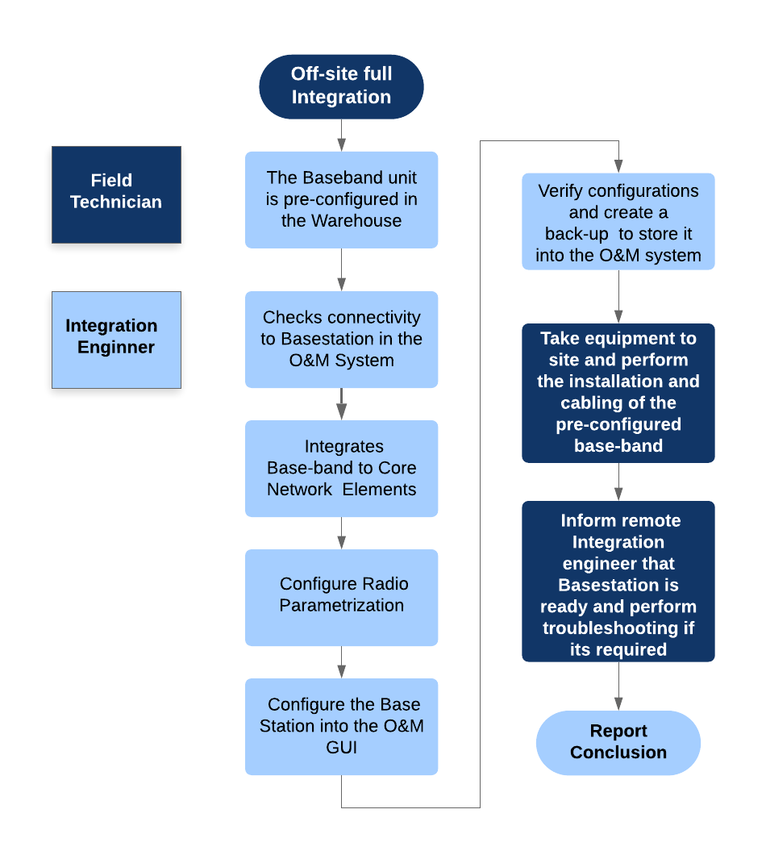

***Insert the Naas Operator Predefined Process***

# Details of tools and testers

|  |  |  |
| --- | --- | --- |
| Laptop | 1 | Tested Laptop minimum requirements : |
| OS System | 1 | As indicate Vendor Documentation |
| Connection Manager | 1 | As indicate Vendor Documentation |
| Power Supply | 1 | As indicate Vendor Documentation |
| Cat-5 Patch Cable | 1 | As indicate Vendor Documentation |
| ***Insert the Required Tools to perform the Commissioning*** | | |

# Prerequisites

|  |
| --- |
| Attachment of the TX IP plan for network elements must be detailed in the agreed format: |
| Attachment of RAN LLD parametrization is detailed in the agreed format: |
| Transmission Commissioning has been completed and tested |
| Commissioning and Integration Scrips has been elaborated previously |
| Access Request form has been submitted to site owner |

# Network Access Request

* Call NOC #6163153135
* Provide them Site NAME , SITE ID , ACTIVITY
* Provide your Name and Company
* Provide Task that you will made
* Provide Expected Time

***Insert the Naas Operator Administrative Procedures***

# Connection Diagram

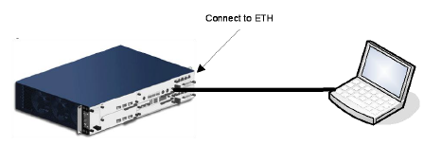

***Insert a diagram showing how to connect into the Base Station for Commissioning***

*The Base Band provides a web-based local maintenance terminal (LMT) for configuring and troubleshooting. The LMT will be used to commission the site and check status.*

# Equipment Description

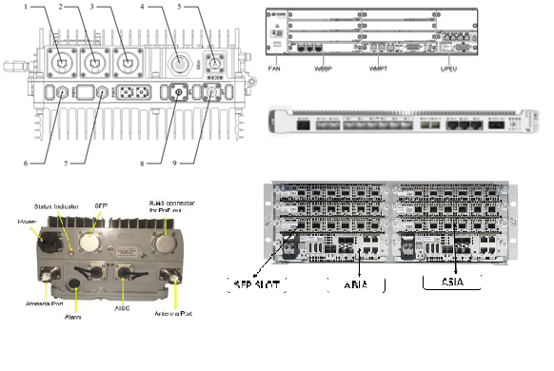

***Insert the description of the baseband that details clearly their physical interfaces***

# Local Commissioning of the Base Station

Example:

|  |  |
| --- | --- |
| **Change IP Address on Laptop** | |
| **Step** | **Task /Observation** |
| 1 | Connect a standard Ethernet cable from the local terminal to the LMT port of the Baseband: |
| 2 | Go to the Start (Windows) Button, and select Search Programs and Files, and type |
| 3 | Under Programs, **cmd.exe** is listed, right click on it and select **Run as administrator**. |
| **4** | When User Access Control asks, Do you want to allow the following program to make |
| 5 | In the command window that opens type:  netsh interface ip set address name="Ethernet" static 169.254.2.1  255.255.255.0 169.254.2.2 |
| 6 | Check that the "Local Area Connection" or "Ethernet" IP address of the computer has been  netsh int ip show addresses "Ethernet" |
| **Connect to Base Station** | |
| **Step** | **Task /Observation** |
| 1 | Open a browser and connect to the Baseband Emergency Access window.  https://IP ADRESS OF BASEBAND |
| 2 | Fill in Base Band IP Address and click Connect:  In the Username field type: **User**  In the password Field type: **Pass** |
| **Load Configuration Script** | |
| **Step** | **Task /Observation** |
| 1 | Click Tools 🡪 Commission Base Station: |
| 2 |  |
|  | Verify the progress and check of a backup of the configuration this is performed by GUI or CI commands |
| ***Insert the STEP-BY STEP procedure to connect into the Local and maintenance system of the base station and load the pre-elaborated scripts***  ***NOTE: Vendors use Configuration Scripts in different ways.***  ***Some allow whole configuration in a single script other require additional steps other vendor documents their Base Station configuration through their GUI but all support a script based configuration. This Step commonly configure the Base Station Hardware , Ethernet Ports , IP configurations to Core Elements*** | |

# Preparing integration tasks

|  |  |
| --- | --- |
| **Change IP Address on Laptop** | |
| **Step** | **Task /Observation** |
| 1 | Connect to the O&M system this may be through a remote desktop , |
| 2 | Download and Install CLI tools this must be specified by each vendor. |

# Integration

|  |  |
| --- | --- |
| **Loading Signaling Network** | |
| **Step** | **Task /Observation** |
| 1 | Transport Network configuration defines these following Base Station configurations :   * IpAccessSctp * Sctp * TermPointToMme * And sets these following parameter : * eNBId * eNodeBPlmnId |
| **Loading Radio Network** | |
| **Step** | **Task /Observation** |
| 1 | Radio Network configuration defines these following base station configurations :   * EUtranFrequency * EUtranCellFDD or TDD * earfcnul & earfcndl * ulChannelBandwidth & dlChannelBandwidth * tac (Tracking Area Code) * cellId, physicalLayerCellIdGroup & physicalLayerSubCellId * noOfTxAntennas & noOfRxAntennas |
| **Feature Configuration** | |
| **Step** | **Task /Observation** |
| 1 | Script Feature State Activation will enable the feature state of the expected ones. Example of features :   * ROHC * TTI BUNDLING * CARRIER AGGREGATION * IPSEC * FAST RETURN * CSFB |
| **Loading QoS** | |
| **Step** | **Task /Observation** |
| 1 | QCI Mapping to DSCP configuraiton |
| **Loading Frequency Relation** | |
| **Step** | **Task /Observation** |
| 1 | Frequency Relation defines information of a specific :   * UtraNetwork * UtranFrequency * UtranFreqRelation |
| **Loading EUtran Cell Relation script** | |
| **Step** | **Task /Observation** |
| 1 | EUtran Cell Relation defines information of a specific   * EUtranCellRelation |
| ***Insert the STEP-BY STEP Integration Procedure insert expected results***  ***NOTE: Vendors may use CLI commands or GUI based configurations this steps are intended to being performed by Integration Engineer, however a experienced Field Technician/Engineer may perform this set of steps locally*** | |

# Verify Integration

|  |  |
| --- | --- |
| **Verify loaded parameters** | |
| **Step** | **Task /Observation** |
| 1 | * Compare IP configurations with IP setted parameters * Verify Features with RF plan * Verify RF parametrization with RF design |
| ***Verifying the correct settings compared with the TX and RF design can be performed with vendor specific Tools or CLI commands*** | |

# CLI Commands

|  |  |  |
| --- | --- | --- |
| **CLI COMMANDS EXAMPLE** | | |
| 1 | IP CHECK | *LIST IP CONFIGURATION* |
| 2 | BBU ALARM CHECK | *DISPLAY ALARMS* |
| 3 | VSWR CHECK | *DISPLAY VSWR* |
| 4 | BACKUP CHECK | *DISPLAY BACKUP FILE* |
| 5 |  |  |
| 6 |  |  |
| ***Insert specific CLI commands for each vendor (IF command integration was used)*** | | |